//1

SELECT s.lname, g.group_name

FROM students s ,groups g

WHERE s.group_id = g.group_id

AND g.major_id IN (

SELECT m.major_id

FROM majors m

WHERE g.major_id = m.major_id AND m.major_name = 'CSSE'

)

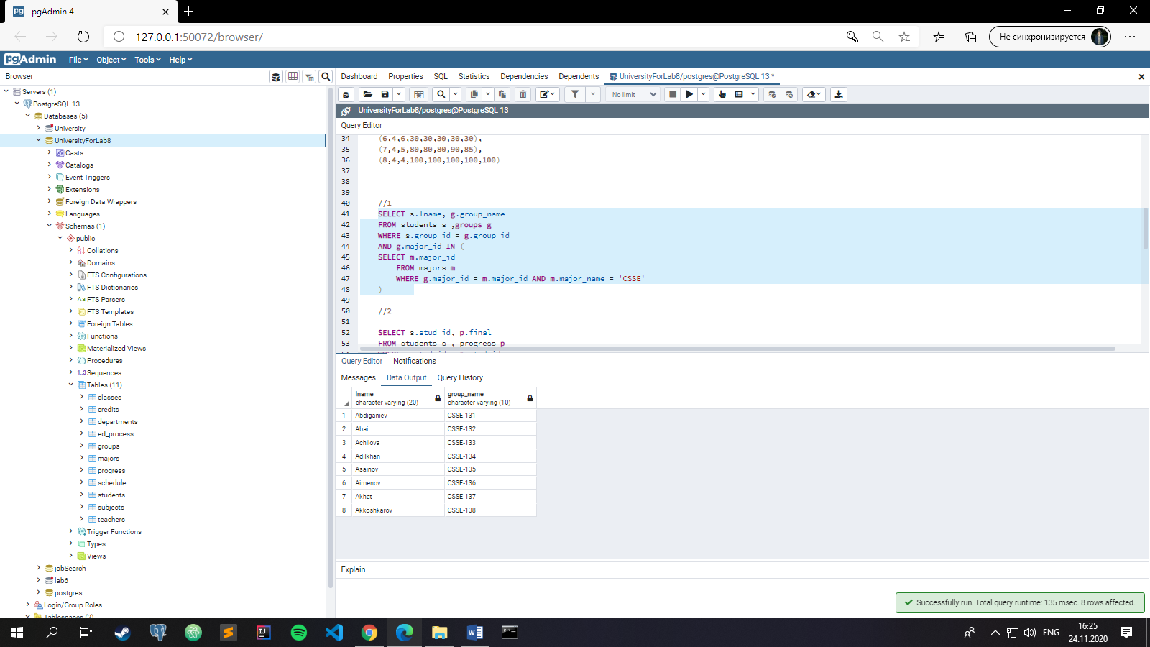

//2

SELECT s.stud_id, p.final

FROM students s , progress p

WHERE s.stud_id = p.stud_id

AND p.final > (SELECT avg(p.final) FROM progress p)

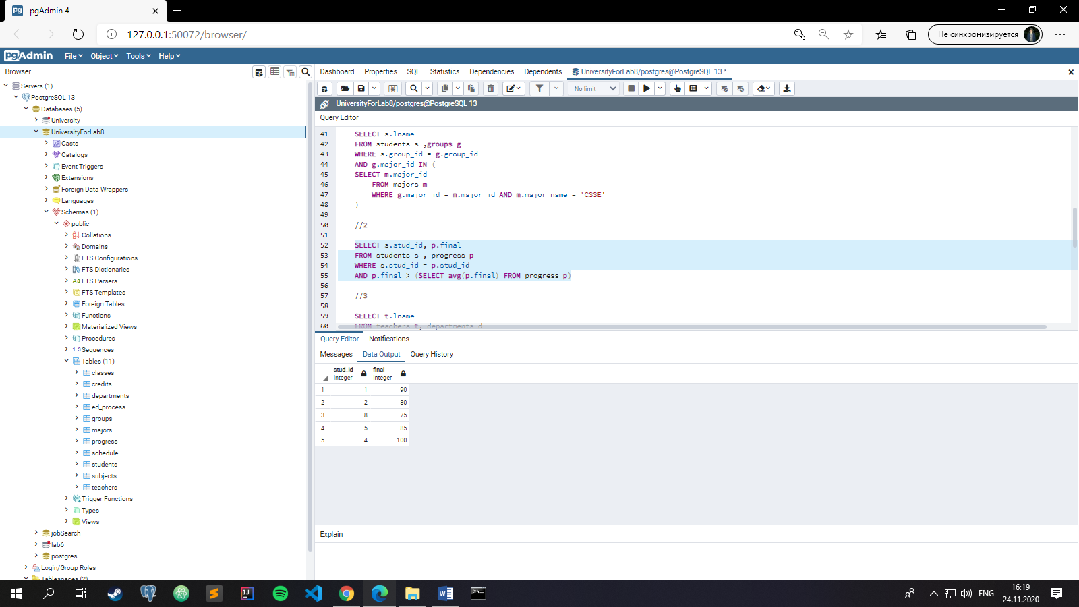

//3

SELECT t.lname, d.dep_name

FROM teachers t, departments d

WHERE t.dep_id = d.dep_id

AND t.dep_id IN(

SELECT d.dep_id

FROM departments d

WHERE d.dep_id = 1 or d.dep_id = 2

)

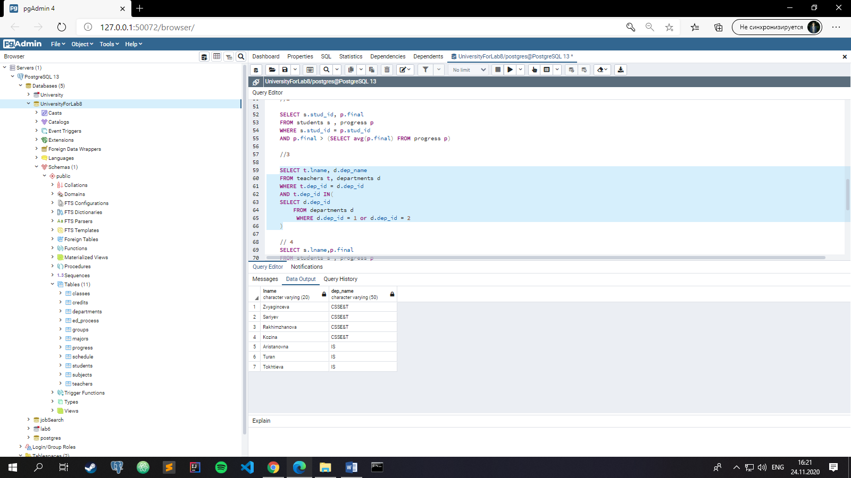

// 4

SELECT s.lname,p.final

FROM students s , progress p

WHERE p.stud_id = s.stud_id

and p.final NOT IN(

SELECT p.final

FROM progress p

WHERE p.final < 50

)

UNION

SELECT s.lname,p.final

FROM students s , progress p

WHERE p.stud_id = s.stud_id

and p.final IN(

SELECT p.final

FROM progress p

WHERE p.final < 50

)

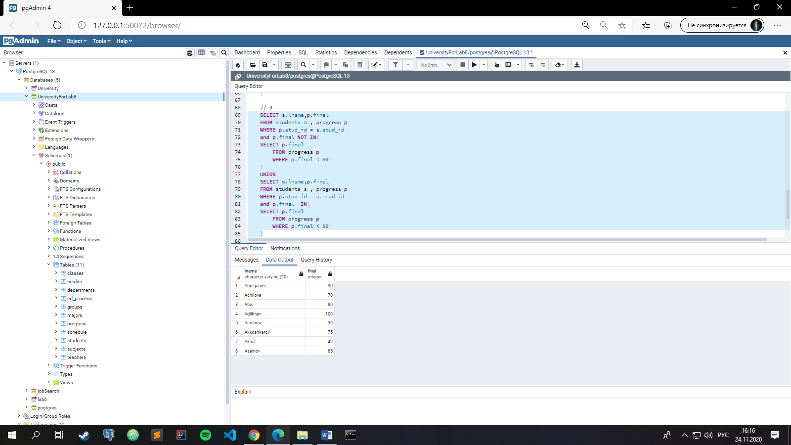

//5

SELECT s.lname

FROM students s

WHERE length(s.lname) > ALL(SELECT length(t.lname) FROM teachers t)

